EUROPEAN PHOTO COMPETITION
Entries invited from our European Partner Schools in
Croatia, England, Estonia, Norway, Portugal, Turkey
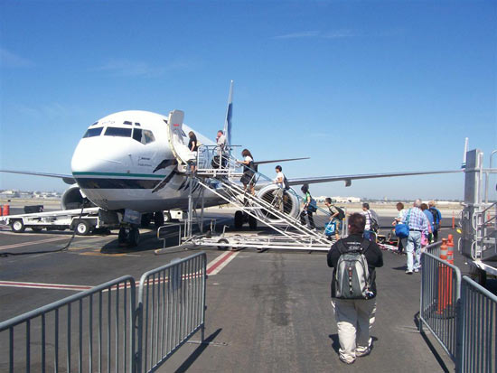
THEME: Carbon Footprint
Any photo representing Carbon Footprint, good practice, bad practice etc., see samples on this poster. Interpretation of topic as well as actual photo will count
ENTRIES: 5 per school. Project coordinator will decide best 5 photos to forward to me (Liam Burke, Whitecross School)
CLOSING DATE: Friday, July 1st, 2011
ENTRIES BY EMAIL ONLY: whitecrossns@gmail.com

PRIZES*: There will be €200 worth of prizes for the best 5 entries with €100 going to the best overall entry.
SCHOOL PRIZE: The winning entrant will also receive a framed copy of that entry for display in his/her school
*Whitecross School will be sponsoring these prizes

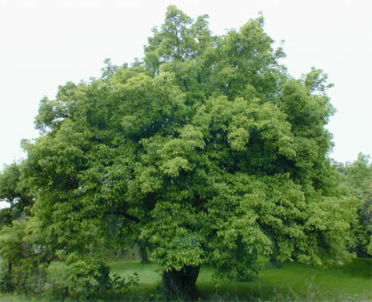
If you’re not in you can’t win!!
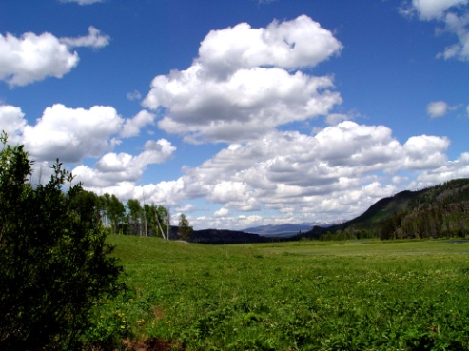
Entries by email only to whitecrossns@gmail.com

